****A Brief History of the****

****Arctic National Wildlife Refuge****

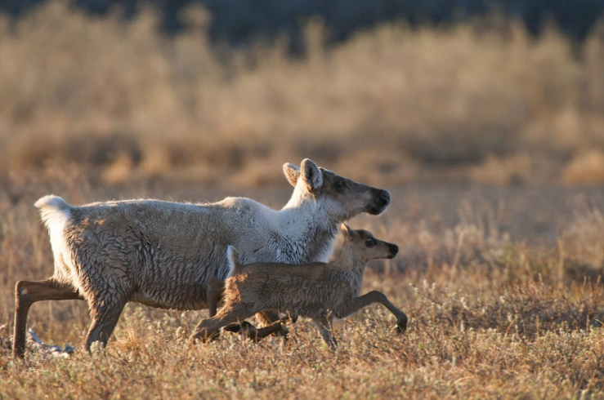

**The Arctic National Wildlife Refuge is the largest unit in the National Wildlife Refuge System, comprising 19.6 million acres of wild lands including its biological heart, the coastal plain. After decades of legislative protection, the coastal plain was opened to oil and gas development as part of the ‘Tax Cuts and Jobs Act’ passed in December of 2017.**

# **Refuge Values**

**More than 250 animal species rely on the Arctic Refuge’s diverse habitats including wolves, muskoxen, wolverines and caribou. Numerous species of birds rely on the Arctic Refuge during the summer months before migrating to every state in the U.S. and across six continents. Female polar bears build dens along the coastal plain to give birth to their young, and are doing so with greater frequency. Though polar bears prefer to spend the majority of their time on the drifting pack ice in the Arctic Ocean, sea ice is receding due to climate change, making land denning sites in the Arctic Refuge increasingly important for polar bears.**

**According to Gwich’in oral tradition, the resources of the Arctic Refuge have sustained the Gwich’in people for thousands of years. Each spring, the Porcupine Caribou Herd migrates approximately 1,400 miles north to its calving areas on the coastal plain to give birth. Then, during the winter, the herd disperses throughout the southern part of the Arctic Refuge and into Canada. Estimates show that an individual caribou may travel more than 3,000 miles over the course of a single year. Protecting the calving grounds of the Porcupine Caribou Herd in the Arctic Refuge is crucial to protecting the culture of the Gwich’in people and ensuring their food security.**

# **Political History**

**The fight to protect this area began in the early twentieth century by a group of visionary conservationists led by Olaus and Margaret Murie, who campaigned to establish the nation’s first ecosystem-scale conservation area. On December 6, 1960, President Dwight Eisenhower made their vision a reality by establishing the 8.9-million-acre Arctic National Wildlife Range specifically for its “unique wildlife, wilderness, and recreational values.” In 1980, President Jimmy Carter continued this legacy by expanding the area, designating much of the land as protected Wilderness and renaming it the Arctic National Wildlife Refuge. However, the 1.5-million-acre coastal plain, the biological heart of the Arctic Refuge, was left unprotected. Congress and the Trump administration should take steps to secure the strongest protections possible for this iconic landscape.**

**A majority of the American people have consistently supported protecting the Arctic Refuge’s coastal plain for more than half a century, and that support remains strong today. Starting in 1986, legislation to protect the Arctic Refuge coastal plain as Wilderness has been introduced in every Congress. Support for the Arctic Refuge over the years has been bipartisan and members from both parties continue to come together to safeguard our natural heritage on behalf of the American people.**

**Despite this passionate support, legislative attempts to authorize drilling within the Refuge’s coastal plain started soon after its designation and were pursued year after year. Such drilling attempts were debated and defeated nearly 50 times in Congress. In December of 2017, after three decades of debate, drilling was finally authorized as part of a massive legislative tax package, the final version of which includes a dangerous provision calling for drilling revenue from the coastal plain of the Arctic Refuge. This is the first time any national wildlife refuge in the United States has been opened and re-designated for oil and gas development, and is the single most destructive attack on the wilderness, wildlife and subsistence resources of a national wildlife refuge in modern history.**

**Every national wildlife refuge across the United States has a regularly updated Comprehensive Conservation Plan that guides long-term management of those refuges. Adding an oil and gas purpose contradicts the current management plan for the Arctic Refuge, which includes Wilderness recommendations for areas of the Arctic Refuge, including the coastal plain, and was supported by millions of Americans.**

# **What Comes Next**

The Trump administration and its allies in Alaska’s congressional delegation have been very clear on their intentions to push forward with leasing in the Arctic Refuge, and are doing so at a reckless and aggressive pace. Over the next several years, there will be multiple opportunities for the public and Congress to comment directly to this administration on its plans to lease and drill the iconic Coastal Plain.

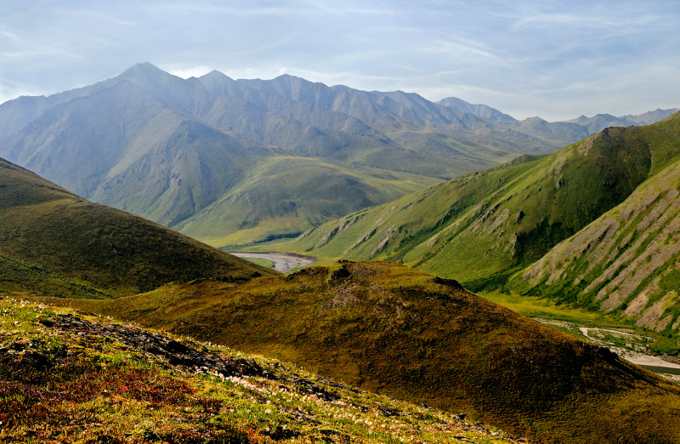Despite these threats, Americans have stood together to protect the Refuge for decades, and today there is a bigger, stronger and more diverse coalition than ever that stands ready to continue the fight to ensure this iconic landscape is protected for generations to come.